**©Topkina Holdings LTD**

# HANGERS TAVERN

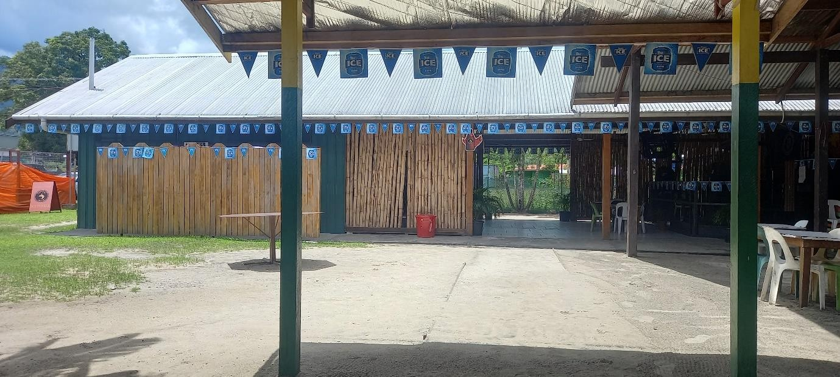

**Hangers Tavern** is a subsidiary of Topkina Holdings Ltd. First established in the year 2009 the Tavern is fully licenced to sell Liquor. Located in the Heart of Arawa town, the Tavern was built to provide a place for people to socialize and provide a place to raise funds for worthy causes. Rules and regulation are enforced within the tavern’s premises.

The TAVERN provides a proper place for drinking, socialising and for business personnel to meet with their clients. It also provides a venue for sporting activities such as snooker, boxing and darts.

### AIM AND VISION

Our aim and vision is rehabilitation of Bougainvilleans through socialization and sports.

The Tavern isn’t set for the purpose of providing a convenient drinking and eating place only but also to help social rehabilitation of Bougainville people as a whole because majority of the youths today grew up during the Bougainville crisis and lack social skills.

### OVERVIEW OF THE COMPANY

Page **23** of **28**

**©Topkina Holdings LTD**

### Sporting Venue

The company provides venue for Sporting tournaments.

* Bougainville Amateur Boxing Association runs boxing tournaments towards the end of every year at the Tavern. Boxers All over Bougainville come to participate. Boxing selection trials for Team Bougainville are also held at this venue.
* Annual Darts Competitions are held at the Tavern. Dart selection trials for Team Bougainville are also held at this Venue.
* Snooker Competitions are also held at the tavern. Snooker friendly games are held every day.

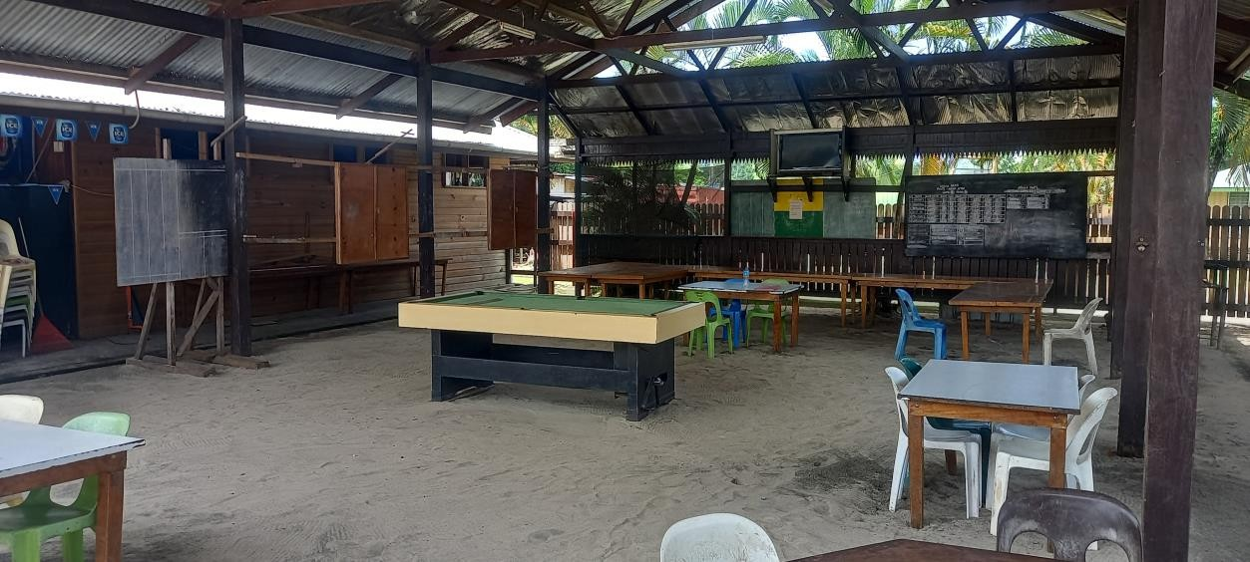

### Meetings

The Tavern also provides a convenient venue for meetings and conferences. Over the past years dozens of meetings has been held successfully without any hassles.

Page **24** of **28**

**©Topkina Holdings LTD**

### Catering

Catering for corporate and social functions can also be provided. We are so far the leading catering service providers in Central Bougainville. Venue is also available for any corporate or social functions.

Here are some Highlights.

|  |  |  |  |
| --- | --- | --- | --- |
| **Year** | **Occasion** | **Venue** | **Client** |
| **2014** | Prime Minister’s State Dinner during  the Prime Minister’s Visit. | Hangers  Tavern | ABG |
| **2014** | Farewell Dinner for the Minister of Planning and Monitoring Mr Charles  Able (Sea Food Buffet) | Hangers Tavern | ABC |
| **2014** | Aropa Airport Re-opening catering for  VIPs and Prime Minister (Finger food) | Aropa  Airport | ABG |
| **2014** | Prime Minister’s Farewell Dinner  (Buffet) | Hangers  Tavern | ABG |

Due to high demand in the catering area, we have now opened a fast food restaurant located in the clubs premises.

### Fundraising Activities

The Tavern provides venue for fundraising activities for individuals, sporting groups, church groups and schools. We have so far helped a lot of individuals, sporting groups and schools to host fundraising activities at the Tavern.

Page **25** of **28**

**©Topkina Holdings LTD**

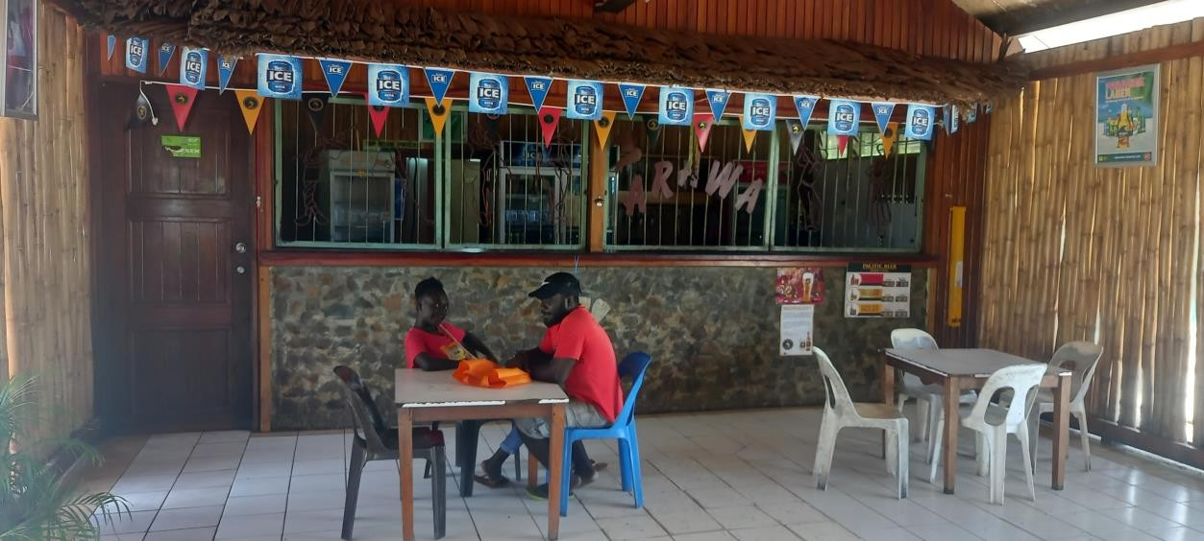

Page **26** of **28**

**©Topkina Holdings LTD**

## CONTACTS

|  |
| --- |
| **Head Office & Postal Address Section 15, Allotment 73, Arawa P O Box 218**  **Arawa,**  **Autonomous Region of Bougainville Email:** [**cpokona@gmail.com**](mailto:cpokona@gmail.com) |
| **Clarence Pokona – Director/General Manager P O Box 218, Arawa**  **Autonomous Region of Bougainville Digicel:7237 5548**  **Email:** [**cpokona@gmail.com**](mailto:cpokona@gmail.com) |
| **Elizabeth Anne Matsia Pokona – Admin Manager P.O.Box 218, Arawa**  **Autonomous Region of Bougainville Digicel:73675708**  **Email: N/A** |
| **Bankers**  **Bank of South Pacific (BSP) Branch: Buka / Arawa**  **Topkina Holdings ltd has existing Bank Account with BSP Bank.** |

Page **27** of **28**

**©Topkina Holdings LTD**

Page **28** of **28**